**INSTAGRAM APPLICATION (LOGIN, MESSAGE)**

**TEST PLAN DOCUMENT**

**CONTENTS**

1)Objectives

2)Scope of Testing -

2.1) In scope

2.2) Out scope

3)Test Methodology

4)Test Environment Setup

4.1) Dev Testing Environment

4.2) Client Testing Environment

5)Approach

6)Risk Management

7)Team Organization

8)Defect Management

9)Entry Criteria and Exit Criteria

10)Test Automation

11)List of Test Deliverables

12)Templates

13)References

**1)OBJECTIVES**

The testing team will review and understand system requirements and design documents that will drive our test scenarios and test case creation. The testing team will test the login and message features of Instagram application.

**2)SCOPE OF TESTING**

**2.1) INSCOPE**

With reference to the BRD document the following will be tested.

|  |  |
| --- | --- |
| S.NO | DESCRIPTION |
| 1 | Login |
| 2 | Authentication |
| 3 | Integration with Gmail for login |
| 4 | Message |
| 5 | Notifications |

**2.2) OUT SCOPE**

With reference to the BRD document the following will not be tested.

|  |  |
| --- | --- |
| S.NO | DESCRIPTION |
| 1 | Third party Integration (Shopping, Facebook, Threads) |
| 2 | Integration Testing for above applications |
| 3 | Privacy |
| 4 | Content (recommendations, filters, reels, stories, posts, feed) |
| 5 | Backend Infrastructure (servers, databases, API’s) |
| 6 | Legal Compliance (Copyrights) |
| 7 | Testing of beta features |
| 8 | Performance Testing (Load, Stress) and Compatibility Testing |
| 9 | Network Infrastructure (Data center failure, Server maintenance) |
| 10 | Profile management, settings and logout |

**3) TEST METHODOLOGY**

Different types of testing are listed below:

|  |  |  |
| --- | --- | --- |
| S.no | Test type | Comments |
| 1 | Unit | Conducted by the dev team in support of the code process. |
| 2 | Smoke | QA will run a smoke test to verify the build. If any major issues are found, the build will be rejected. |
| 3 | Retest | QA performs retests to check the functionality in a modified build to confirm bug fixes and check the build with multiple inputs. |
| 4 | Regression | Test cases are re-executed to check the functionality of the application is working fine and the new changes have not produced any bugs. |
| 5 | Sanity (opt) | Performed when a software build is received (with minor cede changes) from the development team. |
| 6 | End to end testing | Performed to validate the complete effectiveness and functionality of the application from start to finish. |
| 7 | GUI/UI | Verifying graphical elements and interactions and validating the style font, color palate is consistent through the application. |
| 8 | Usability | Validates the user-friendliness of the applications. |
| 9 | Security | Performed to discover the weakness, risks or threats in the login application. |
| 10 | Globalization | Validate the time and date formats of messages. |
| 11 | User acceptance | End user testing will be conducted if required. |

**4) TEST ENVIRONMENT SETUP**

The required test environments for client and server side are mentioned below.

**4.1) DEV TESTING ENVIRONMENT**

* Testing server
* Database
* Network monitoring tools
* Security testing tools
* Monitoring and Loging (Server logs)

**4.2) CLIENT TESTING ENVIRONMENT**

* Web browser (chrome, safari, Firefox, Edge)
* Network Environment (Wi-Fi and mobile data)

**5) TEST APPROACH**

Test Approach can be shown by using high level scenarios or flow graphs. Below is the flow graph for Instagram application testing for login and message module.

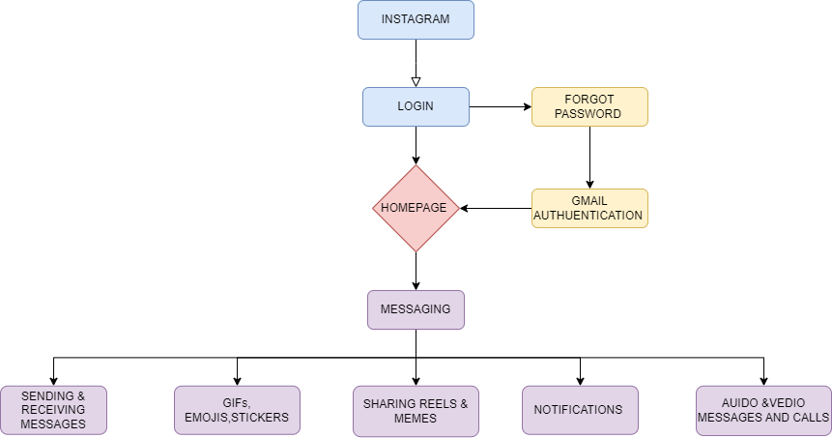

**6) RISK MANAGEMENT**

A strategy to prepare for and lessen the effects of threats faced by a business.

|  |  |  |  |  |
| --- | --- | --- | --- | --- |
| S.No | Risk Title | Risk Description | Impact | Mitigation Plan |
| 1 | Resources | There must be enough resources available to conduct testing | High | Test lead will regularly monitor resource allocation and raise issues to management. |
| 2 | Requirement | Clearly define functional and UI requirements along with any changes that are communicated to allow updates in the test plan | High | QA should be included in the change control process and should conduct risk assessment, make resource allocation adjustments. |
| 3 | Environment Readiness | Environment should be set up properly before it's handed over to QA | High | Environment readiness is validated via smoke test. |
| 4 | Project Documentation Repository | Shared project repository by both QA and dev | Medium | Use one centralized repository for development and testing team. |
| 5 | Test execution duration | If a QA is given multiple projects with same deadlines | High | Project Prioritization is essential in this case. |

**7) TEAM ORGANIZATION**

Below we have the team organization with all the team members' roles and responsibilities.

|  |  |  |  |
| --- | --- | --- | --- |
| S.No | Role | Name | Responsibility |
| 1 | Test Manager | Divya | Write and review the test plan.  Conduct meetings with development, testing team and customer. Sign off release note |
| 2 | Test Lead | Varsha | Prepare the test plan, RTM and reports. Conduct daily meetings and assign modules and handle schedules. |
| 3 | Sr. Test engineer | Jessy | Execute the test documents which consists of test cases, defect tracking, RTM for respective modules and communicate to test lead. |
| 4 | Jr. Test Engineer | Aryan | Prepare the test execution report |
| 5 | Business Analyst | Jahnavi | Provides BRS & BRD document |
| 6 | Sr.Software Engineer | Mahesh | Develops the application based on requirement specification |

**8) DEFECT MANAGEMENT**

Following are the various aspects of defect tracking:

|  |  |  |
| --- | --- | --- |
| S.No | Defect | Priority |
| 1 | Authentication failure | High |
| 2 | Login issues using Gmail | High |
| 3 | Password reset failure | High |
| 4 | Message interface defects | High |
| 5 | Message delivery issue | High |
| 6 | Attachment handling errors | Medium |
| 7 | UI & UX issues | Medium |
| 8 | Time & date issues | Medium |
| 9 | Reaction to message issue | Medium |
| 10 | Translation issues in application | Low |

**9) ENTRY CRITERIA & EXIT CRITERIA**

ENTRY CRITERIA FOR DEV

* 100% code completion
* Code review feedback from peer developer and Project manager approval for the same.
* Unit test results shared by development team.
* Release notes from dev team with changes and defects fixed details.
* Smoke testing completed by dev team after development and deployment.
* White box testing completed with results.

ENTRY CRITERIA FOR PROD

* System integration testing execution 100% completed and sign off provided

**EXIT CRITERIA**

EXIT CRITERIA FOR DEV

* No s1 and s2 defects.
* 100% test execution completion for all supportive platforms.
* Test summary report with metrics
* Sign off from code lead for code promotion.

EXIT CRITERIA FOR PROD

* All the release items are validated.

**10) TEST AUTOMATION**

Test automation is the process of using automation tools to maintain test data, execute tests, and analyze test results to improve software quality.

Automated scripts are designed to validate the login page with various inputs. In which we give continuously different usernames and passwords and check the application stability.

**11) LIST OF TEST DELIVERABLES**

These are the deliverables which are provided to the customer after the testing.

* Test plan
* Test scenarios
* Test cases
* Test execution summary and metrics
* Test execution reports
* Defect report.
* RTM execution reports.
* System integration Test execution report
* UAT execution report and log

**12) TEMPLATES**

Below are the templates that will be used for the project.

* Test plan Template.
* Test scenario Template
* Test case Template
* Defect Status Template
* RTM

**13) REFERENCES**

* BRD